BEACONHOUSE NATIONAL UNIVERSITY


LAB 7

Name: Saad Mughal
BNU ID: F2023-009

Total Marks: /10
Due Date: 24 Mar, 2025

Lab Manual
For
COAL(SEC_B)
Course Instructor | Ms. Nimra Abbas
Lab Instructor | Ayesha Seher
Semester | Spring 2025

Problem No.1:
Register Indirect Addressing and array + loop implementation
Your task is to develop an assembly program for an embedded system that processes
sensor readings stored in memory. The system collects 10 sensor values and needs to
compute their total sum for further analysis. The memory location of these sensor values
is stored in an array, and each value is 2 bytes (word) in size. Perform a dry run,
explaining each LOC (Line of code*).
Solution:
org 100h ; Set the start address for the program
.model small
.data
arr dw 2, 4, 6, 8, 10, 12, 14, 16, 18, 20 ; Array of 9 words
total dw 0 ; Variable to store the total sum

.code
main proc
; Initialize data segment
mov ax, @data
mov ds, ax

; Initialize sum to 0 and counter to 10
mov ax, 0
mov cx, 10 ; Set loop counter to 10 (for 10 elements)
lea bx, arr ; Load the address of arr into bx

arr1:
add ax, [bx] ; Add the value at the memory location pointed by bx to ax
add bx, 2 ; Increment the pointer by 2 (next word in array)
sub cx, 1 ; Decrement the loop counter (cx)

jnz arr1 ; Repeat loop if cx is not zero

; Store the result in the total variable
mov [total], ax

; Move the result to dx for display or further usage
mov dx, [total]

; Exit the program
mov ah, 4Ch ; Function to exit the program
int 21h ; Call DOS interrupt to exit

main endp
end main
Screenshot:
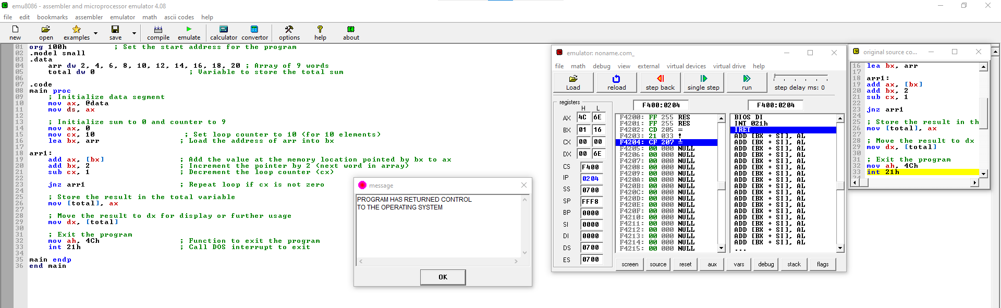

Problem No.2:
Register Indirect Addressing (without loop)
Write a program to add four numbers using Register indirect/ indirect addressing. Also
dry run each LOC.
Solution:
org 100h

.model small
.data
total dw 0
array dw 2, 4, 6, 8

.code
main proc
mov ax, @data
mov ds, ax

mov dx, 0
mov bx, 0

lea bx, array
mov ax, 0

add ax, [bx]
add bx, 2

add ax, [bx]
add bx, 2

add ax, [bx]
add bx, 2

add ax, [bx]

mov [total], ax
mov dx, [total]

mov ah, 4ch
int 21h

main endp
end main
Screenshot:
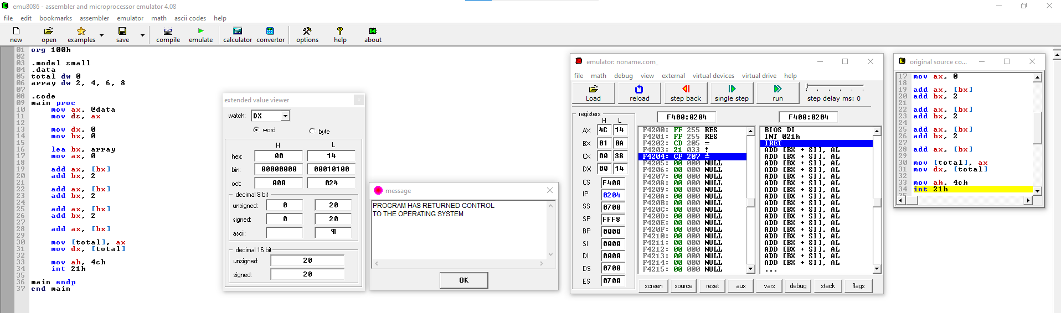
Problem No.3:
A temperature monitoring system in an industrial plant collects 7 temperature readings
every hour. These readings are stored in a fixed memory location in a word-sized (2-byte)
array.
- Access the stored temperature readings using Register + Offset Addressing.
- Compute the total sum of the 7 readings.
- Store the computed sum in memory for later use by another process.

Scenario Details:
- The sensor readings are stored in a contiguous memory block (num1).
- The array starts at a known memory location.
- The program will traverse the array using BX as an index and accumulate the sum in AX.
- Each reading is 2 bytes, so BX is incremented by 2 in each iteration.
- The program will loop until all 10 readings are processed and store the final sum in total.
Solution:
org 100h

.model small
.data
total dw 0
array dw 2, 4, 6, 8, 10, 12, 14

.code
main proc
mov ax, @data
mov ds, ax

mov ax, 0
mov bx, 0
mov cx, 7

l1:
add ax, [array + bx] ; register offset which increments by 2
add bx, 2
sub cx, 1
jnz l1 ; jump until cx is not equals to zero
mov [total], ax ; ax is saved indirectly to the total
mov dx, [total]

mov ah, 4ch
int 21h

main endp
end main
Screenshot:
